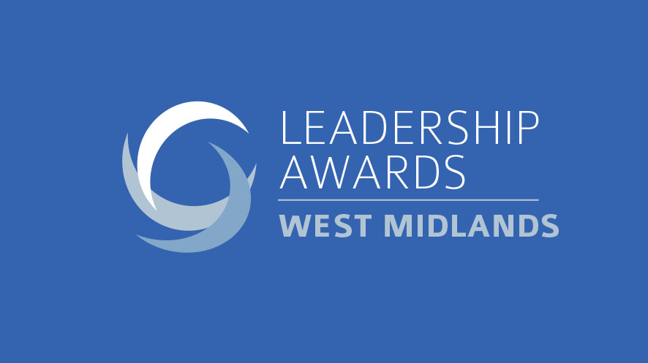

The West Midlands Leadership Awards will celebrate the people that are role models within their organisations and raise the bar for their competitors. The winners will show the qualities of extraordinary leadership and be able to demonstrate the positive impact this has had.

Impact can be measured in a number of ways, including improving financial performance, organisational culture or external reputation, overcoming adversity and challenges or by enabling other people succeed.

Great leadership can also be demonstrated through roles with other bodies where the individual is championing the region, sector or under-represented groups.

Leadership happens throughout an organisation so applicants can be from anywhere in the organisation; at its core Leadership is about mindset and behaviour, not always hierarchy!

The shortlisted individuals and organisations will be those who have made a difference through a real desire to make things better.

Guidelines:
- The entry form can be completed by the person/organisation themselves, or they can be nominated.
- The word count is provided as a guide, not as a strict limit, but please don’t go significantly over.
- Please attach a headshot photo of the nominated individual. For the leadership and change programme awards could you please attach a company logo.
- The entry deadline is Friday 16th August 2019.
- Please email completed entry forms to leadership@thebusinessdesk.com
- For any enquiries please call 0113 394 4324.

Award Categories

Public and third sector leader
The public and third sectors have been under pressure in recent years, requiring its leaders to be innovative and achieve more with less. This has required leaders who can overcome challenges, often under close scrutiny, and drive cultural change in their organisation.

Young leader

This award recognises the best leader aged under 35 (on 01 December 2019) for their ability to make a real difference in their organisation by bringing about positive change and inspiring others around them.

Best leadership programme
Successful companies know that leaders can be developed internally, not just hired externally. This award will go to the company or organisation that has delivered significant improvements through its successful leadership programme.

Diversity and inclusion leader
Increasingly organisations are embracing the benefits of having a diverse workforce at every level and in creating an environment where everyone has a voice. The Diversity and Inclusion leader of the year will be the individual who has championed diversity and inclusion, whether inside their organisation or as part of an outside group or initiative, and worked to improve the opportunities for any under-represented group.

Emerging entrepreneur leader
Entrepreneurial leadership can take a particular form, requiring drive, vision and the ability to bring a team along with you that can collectively achieve great results. This award is for a leader who has led their company for up to three years, whether as founder or has been brought in to push forward a more established business.

Empowering potential leader
This award is for the leader who has inspired and developed people, unlocking potential they may never have known they had. The winning candidate will have helped their team or people in their team to beat their own expectations of themselves and/or the expectations of others.

Professional services leader
The professional services leader of the year will be the individual who is showing strong leadership and having an impact in their firm or further afield.

Company leader (up to 100 employees)
Leading small companies presents its own challenges, often requiring flexibility and a personal touch. This award will go to the best leader in a West Midlands company which employs up to 100 people.

Company leader (100+ employees)
Leadership in a larger company requires effort to ensure the company direction and vision is managed and communicated, often across shifts, sites and even countries. This award will go to the best leader in an organisation which employs more than 100 people.

Transformational leader
Delivering change requires a well-executed plan, but to deliver transformational change requires the added magic ingredient of exceptional leadership. This award will recognise the individual who has achieved that, delivering measurable success in their organisation.

Overall leader (no nominations)
This person will be selected from the other award winners and will be the person or organisation that embodies outstanding leadership and is an exemplar for the whole North.

Entrant details

Entrant (name and organisation):
Job title:
Email: Telephone:
Office address:
Person entering (if different from above):
Name:
Organisation:
Email: Telephone:
Relationship (e.g. colleague, customer, mentor, marketing/PR):

FOR INDIVIDUALS
- Please select the award(s) you are entering:
꙱ Public and third sector leader

꙱ Young leader (aged 35 and under, on December 1, 2019)

꙱ Diversity leader and inclusion leader

꙱ Emerging entrepreneur leader

꙱ Empowering potential leader

꙱ Professional services

꙱ Company leader (up to 100 employees)

꙱ Company leader (100+ employees)

꙱ Transformational leader

- Please summarise the organisation and what it does (up to 100 words)

- Describe the individual’s role in the organisation (up to 100 words)

- Why would this individual be a worthy winner? Please be as specific as possible, providing data where appropriate (please highlight anything that is to be kept confidential), and focusing on how their leadership has had a significant impact and delivered results. Also describe their leadership style and how that has helped them succeed (up to 1,000 words).

FOR ORGANISATIONS

- Please select the award(s) you are entering:

꙱ Best leadership programme

- Name of programme

- Please summarise the division/organisation and what it does (up to 100 words)

- Describe the programme in terms of what it was designed to achieve, its duration, how it fitted in to the wider organisation (up to 200 words)

- Why would the programme be a worthy winner? Please be as specific as possible, providing data where appropriate (please highlight anything that is to be kept confidential), and focusing on how the programme has had a significant impact and delivered lasting results. Also describe any challenges faced and how the programme overcame these (up to 1,000 words).

