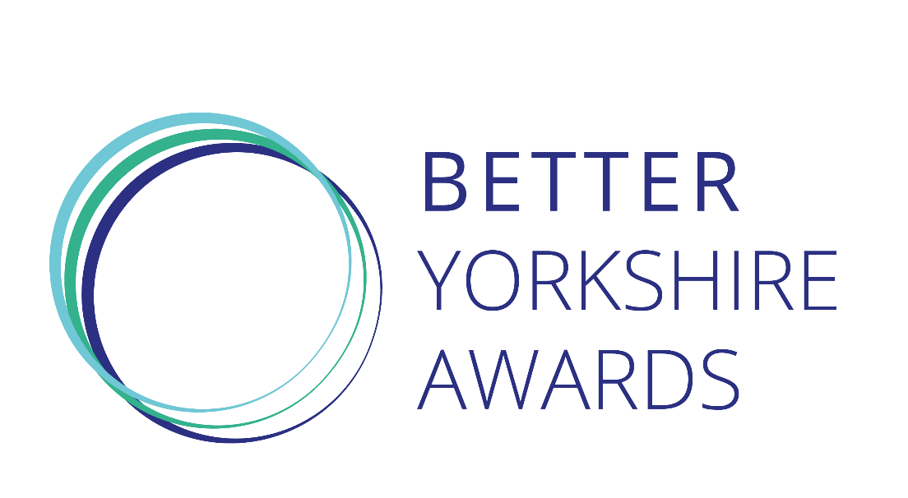
Yorkshire is blessed with organisations and individuals which use their skills and reach to have an impact in their communities. Whether it is badged as corporate social responsibility, inclusive growth, or old-fashioned doing the right thing, there is a lot of fantastic and often unseen work that deserves to be showcased.
That’s why we have created the Better Yorkshire Awards.
The Better Yorkshire Awards are being launched to recognise the very best involvement by businesses and organisations in charitable and social improvement endeavors.

Award categories
Workplace Wellbeing
Employee engagement and workplace wellbeing has come a long way from annual appraisals and a fruit bowl in the canteen.
The best organisations support their people to maximise their potential and minimise the obstacles, working flexibly to create a healthy work-life balance. They will be as much aware of mental health as physical health, both inside the workplace and outside office hours. And they will encourage everyone to make connections, within their organisation and outside, with the communities the business is part of.

Environment
Businesses can have a huge impact on the environment and many are working hard to reduce and offset that. This award will recognise those businesses which are leading on the sustainability agenda – whether through product or system innovation or by making the tough choices which put sustainability above short-term profit, and are creating a genuine green culture in their organisation.

Community and Public Sector Collaboration
Community and Private Sector Collaboration
These awards are to recognise the partnerships which have delivered tangible benefits to a community or third sector organisation. The shortlisted collaborations will be those that go beyond a donation of money or time but use the organisation’s knowledge and networks to create a real and lasting impact on a community group.

Technology for Good
Technology has the ability to cause great disruption, and this is also true for ideas motivated by purpose rather than profit. This disruption can be direct, by improving the quality of life for people or the planet, or indirect, giving people and groups the tools to be their own agents of change.
We are looking for either technology which has been created in Yorkshire, but may have been deployed elsewhere, or solutions which are making a difference within our region.

Social Enterprise
Many business awards overlook the vital contribution that is made by social enterprises. We want that to change. This award will be measured against two broad criteria – the sustainability and success of the organisation itself and the impact it has had on the people it is set up to help.

Small Business (up to 50 employees)
Medium Business (51-250 employees)
Large Business (251+ employees)
These awards will recognise those businesses which can show they are a responsible and active player in their communities. The best will be supportive employers encouraging their people to play their part in their communities, careful about their environmental impact, and open to diversity and inclusivity in all its forms.

Generational Change
Our communities face many ingrained challenges and often the solutions are complex and hard to execute. The Generational Change award is to recognise the partnerships and programmes which have been developed over a long period of time. Perhaps it is an initiative that has worked with one cohort for a number of years, or a regularly-changing group, or it set out with a big ambition and has tirelessly inched towards it.

Better Yorkshire Leader
Creating real and lasting change requires many factors, but one that is ever-present is leadership. Whether that person is the driving force, showing the way, or the backstop, holding it all together in the difficult times, the winner of the Better Yorkshire leader award will have the inspiring mix of vision, persuasion and commitment to bring people together and make a success of it.

