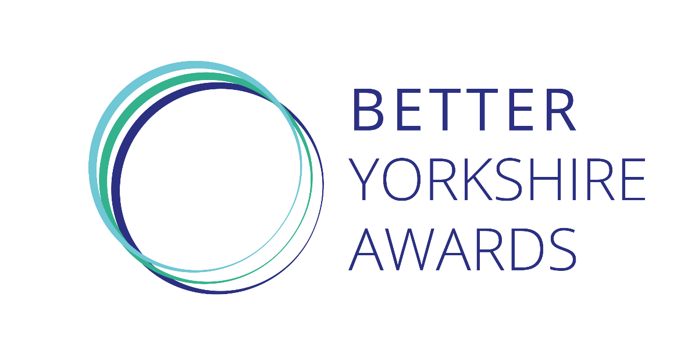
Entrant Details

Organisation: Click to enter text
Number of employees: Click to enter text
Company address: Click to enter text
Name of entrant: Click to enter text
Job title: Click to enter text
Email address: Click to enter text
Telephone: Click to enter text

Person entering (if different from above):
Name: Click to enter text
Organisation: Click to enter text
Email address: Click to enter text
Telephone: Click to enter text

Awards categories
Select which category you are entering (please use a separate form for each category):

☐ Workplace wellbeing ☐ Small business (up to 50 employees)

☐ Environment ☐ Medium business (51-250 employees)
☐ Community and public sector collaboration ☐ Large business (251+ employees)

☐ Community and private sector collaboration ☐ Generational change

☐ Technology for good ☐ Better Yorkshire leader

☐ Social enterprise

Submitting your entry
Please submit your entry to events@thebusinessdesk.com by Friday, June 19, 2020, and also include your company logo.
If you have any questions, please call 0113 394 4543.
Award entry
We are looking for you to tell us:
- the origin and motivations of your CSR activity
- what impact your CSR activity has had, and details of the specific, tangible results
- the challenges that have been overcome
- how you see things developing in the next few years
- what makes this different from what others are doing and therefore worthy of recognition

Please limit your entry to no more than 1,000 words and highlight any information which should be kept confidential.

