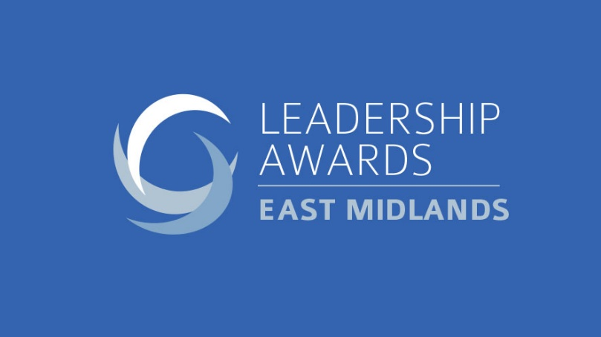

The East Midlands Leadership Awards will once again celebrate the people that are role models within their organisations and raise the bar for their competitors. The winners will show the qualities of extraordinary leadership and be able to demonstrate its impact.

Impact can be measured in a number of ways, including improving financial performance, organisational culture or external reputation, overcoming adversity and challenges or by enabling other people succeed.

In this challenging year, we expect many of the shortlisted individuals will also have demonstrated qualities of resilience, innovation, strong communication as they led their teams and organisations through the coronavirus crisis.

Great leadership can also be demonstrated through roles with other bodies where the individual is championing the region, sector or under-represented groups.

Leadership happens throughout an organisation so applicants can be from anywhere in the organisation; at its core Leadership is about mindset and behaviour, not always hierarchy. The shortlisted individuals and organisations will be those who have made a difference through a real desire to make things better.

Guidelines:
- The entry form can be completed by the person/organisation themselves, or they can be nominated.
- The word count is provided as a guide, not as a strict limit, but please don’t go significantly over.
- Please attach a headshot photo of the nominated individual. For the leadership programme category could you please attach a programme and/or company logo.
- The entry deadline is Friday, July 10, 2020
- Please email completed entry forms to leadership@thebusinessdesk.com

Award Categories

Public and third sector leader
The public and third sectors have been under pressure in recent years, requiring its leaders to be innovative and achieve more with less. This has required leaders who can overcome challenges, often under close scrutiny, and drive cultural change in their organisation.

Young leader

This award recognises the best leader aged under 35 (on 1 December 2020) for their ability to make a real difference in their organisation by bringing about positive change and inspiring others around them.

Best leadership programme
Successful companies know that leaders can be developed internally, not just hired externally. This award will go to the company or organisation that has delivered significant improvements through its successful leadership programme.

Diversity and inclusion leader
Organisations are benefiting from having a diverse workforce at every level and in creating an environment where everyone has a voice. Those shortlisted will have championed diversity and inclusion, whether inside their organisation or as part of an outside group or initiative, and worked to improve the opportunities for any under-represented group.

Emerging entrepreneur leader
Entrepreneurial leadership can take a particular form, requiring drive, vision and the ability to bring a team along with you that can collectively achieve great results. This award is for a leader who has led their company for up to three years, whether as founder or has been brought in to push forward a more established business.

Empowering potential leader
This award is for the leader who has inspired and developed people, unlocking potential they may never have known they had. The winning candidate will have helped their team or people in their team to beat their own expectations of themselves and/or the expectations of others.

Professional services leader
The professional services leader of the year will be the individual who is showing strong leadership and having an impact in their firm or further afield.

Company leader (up to 100 employees)
Leading small companies presents its own challenges, often requiring flexibility and a personal touch. This award will go to the best leader in a Northern company which employs up to 100 people.

Company leader (100+ employees)
Leadership in a larger company requires effort to ensure the company direction and vision is managed and communicated, often across shifts, sites and even countries. This award will go to the best leader in an organisation which employs more than 100 people.

Transformational leader
Delivering change requires a well-executed plan, but to deliver transformational change requires the added magic ingredient of exceptional leadership. This award will recognise the individual who has achieved that, delivering measurable success in their organisation.

Overall leader (no nominations)
This person will be selected from the other award winners and will be the person or organisation that embodies outstanding leadership and is an exemplar for the North.

