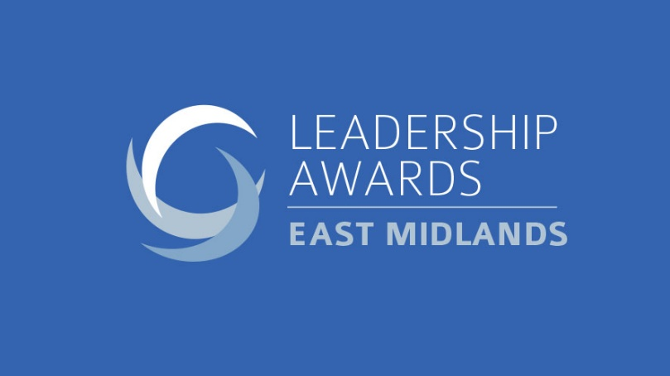

Guidelines:
- There is more information about the categories on TheBusinessDesk.com website, in the events section.
- The entry form can be completed by the person/organisation themselves, or they can be nominated.
- The word count is provided as a guide, not as a strict limit, but please don’t go significantly over.
- Please attach a headshot photo of the nominated individual. For the leadership programme category could you please attach a programme and/or company logo.
- The entry deadline is Friday, September 11, 2020
- Please email completed entry forms to leadership@thebusinessdesk.com

Entrant details

Entrant (name and organisation):
Job title:
Email: Telephone:
Office address:
Person entering (if different from above):
Name:
Organisation:
Email: Telephone:
Relationship (e.g. colleague, customer, mentor, marketing/PR):

FOR INDIVIDUALS
- Please select the award(s) you are entering:
꙱ Public and third sector leader

꙱ Young leader (aged 35 and under, on December 1, 2020)

꙱ Diversity leader and inclusion leader

꙱ Emerging entrepreneur leader

꙱ Empowering potential leader

꙱ Professional services

꙱ Company leader (up to 100 employees)

꙱ Company leader (100+ employees)

꙱ Transformational leader

The overall leader will be chosen from the award winners.

- Please summarise the organisation and what it does (up to 100 words)

- Describe the individual’s role in the organisation (up to 100 words)

- Why would this individual be a worthy winner? Please be as specific as possible, providing data where appropriate (please highlight anything that is to be kept confidential), and focusing on how their leadership has had a significant impact and delivered results. Also describe their leadership style and how that has helped them succeed (up to 1,000 words).

FOR BEST LEADERSHIP PROGRAMME ENTRIES

- Name of programme

- Please summarise the division/organisation and what it does (up to 100 words)

- Describe the programme in terms of what it was designed to achieve, its duration, how it fitted in to the wider organisation (up to 200 words)

- Why would the programme be a worthy winner? Please be as specific as possible, providing data where appropriate (please highlight anything that is to be kept confidential), and focusing on how the programme has had a significant impact and delivered lasting results. Also describe any challenges faced and how the programme overcame these (up to 1,000 words).

